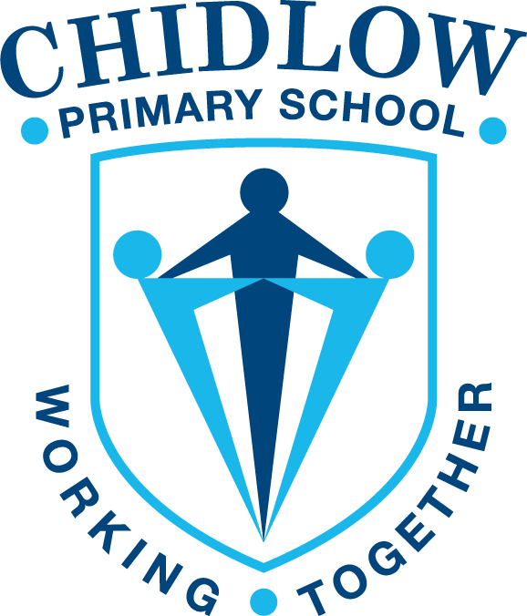

2025 Annual Report

From the Principal
Chidlow Primary School is a small level 4 school in the Perth Hills that provides a personal and community-centred approach to education. The school maintains a positive reputation both within the school and wider community and has a very supportive parent base with a strong School Board and P&C.
Throughout 2025, the school continued to implement the Talk 4 Writing program and maintained Spelling Mastery across our Years 3 – 6 and Sounds Write for our K-2 students.
This report hopes to accurately reflect the commitment and professionalism of the school staff. It highlights the achievements and levels of engagement of our students across a wide range of activities. Our School Community is also recognised for their ongoing support and involvement in delivering quality education to the students at Chidlow Primary School. I would like to take this opportunity to formally acknowledge and thank the school staff and parents who have dedicated time and energy to provide outstanding educational opportunities for the students at Chidlow Primary School. We continue to value the effective partnership between the school and the Chidlow Community.
Amanda McCormack

P&C
Chidlow PS is supported by a small, but very active, group of parents who work tirelessly to support our students and their educational programs. The P&C were able to maintain our commitments to subsidise our school camp, run the canteen, hold various stalls, purchase book prizes, support our end of year celebration day and help to pay for Smart TV’s for our classrooms.
I would like to thank the P&C’s executive committee and members for their constant commitment to our school.
School Board
The School Board has been active this year and regularly meet to review and make recommendations regarding Chidlow PS. They have endorsed our 2026 School Development Days, reviewed and approve recommendations and changes for our contributions and charges and discussed and noted the 2026 school budget. The School Board members were available to parents on our Open Night to explain their role and offer support to parents. The School Board play a vital role in supporting the school to set and achieve future directions and we thank them for their valuable input.
Student Numbers (as at Semester 2 2025)

Primary | Kin | PPR | Y01 | Y02 | Y03 | Y04 | Y05 | Y06 | Total
Full time | (13) | 11 | 19 | 14 | 12 | 15 | 20 | 19 | 124
Part Time | 21

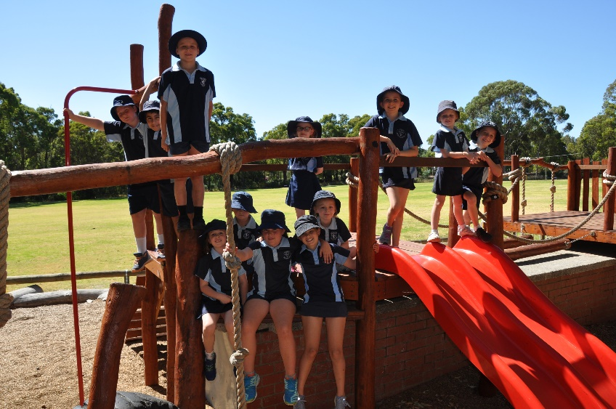

Staffing
Chidlow PS staff are committed to providing students with the best possible learning programs. Staff continually strive for improvement and work together to reflect on their teaching strategies. Staff also engage in performance management with a focus on self reflection and improvement. Chidlow PS is made up of 1 full time Principal, 1 full time Deputy Principal, 1 full time Manager of Corporate Services, 2 part time School Officers, 6 full-time Teachers, 2 part-time Teachers, 3 part-time Special Education Needs Assistants, 2 part-time Mainstream Education Assistants, 1 part-time School Psychologist, 1 part time School Chaplain, 2 Cleaners and 1 part-time Gardener.

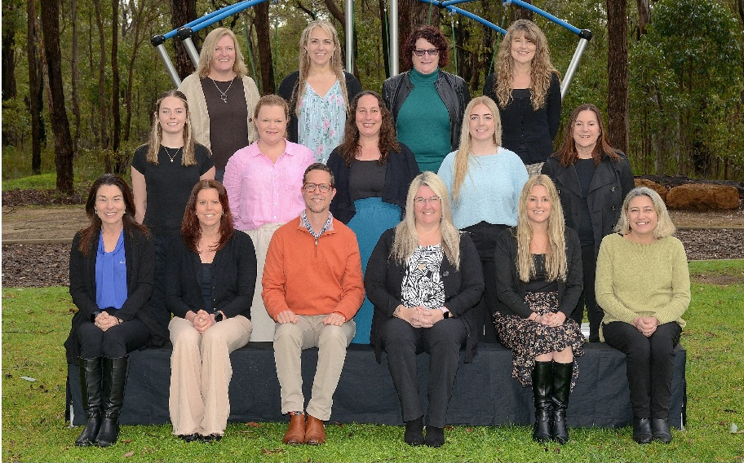

Student Attendance
In 2025 Chidlow PS aimed to have an attendance rate of 89.7% which is slightly above the WA Public Schools average. Attendance will remain an area of focus going forward.

 | School | WA Public Schools
2023 | 89.8% | 88.9%
2024 | 91.1% | 89.4%
2025 | 89.7% | 89.1%

English
2025 saw us continue with the Spelling Mastery program across our Year 3 – 6 cohort with great success. The students were tested at the end of the year and 98% of our students made improvements and were able to achieve mastery at their spelling level. Teachers utilise the Talk 4 Writing program with teachers attending the professional learning throughout the year to upskill them on both fiction and non fiction programs. SoundsWrite remained a focus for the year with Phonemic Awareness a large focus in the Early Childhood area.

Mathematics
We have continued with our implementation of the Origo Stepping Stones program and teachers are utilising this across all areas of math supplemented with math games. We are continuing our review of best practice in teaching math with one of our Senior Teachers taking on this role.

Italian
Italian remained as our languages program with students from PP – Year 6 engaged in their lessons. The students had the opportunity to learn about the language and culture of Italy.

Chidlow Primary School 2025
Financial Summary as of 31 December 2025
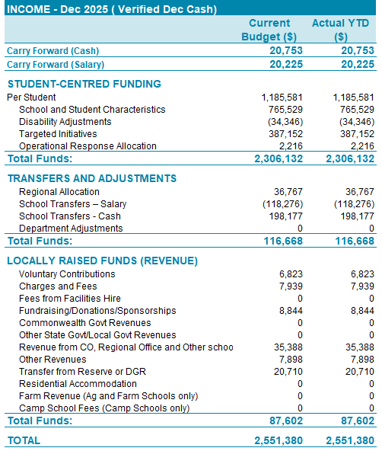
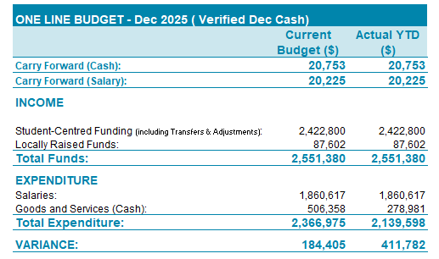

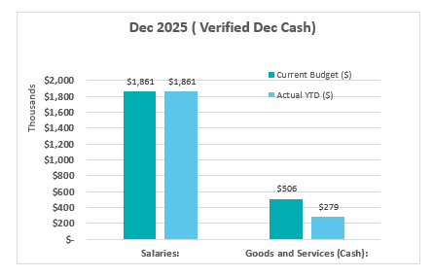
Goods and Services
Vs Salary Expenditure

Goods and Services Expenditure Budget vs Actual
Locally Generated Revenue
Budget vs Actual

